POWER SPECTRAL DENSITY (PSD) ANALYSIS OF PHASE MODULATED (PM) SIGNALS USING MATLAB
Analog and Digital Communication — Experiment 8
Date of Experiment | 12/10/2026
Performed By | Lokesh A
Register Number | 192512293
1. Aim
To generate a Phase Modulated (PM) signal using MATLAB, obtain its frequency spectrum and power spectral density (PSD), and calculate the phase deviation and approximate bandwidth.
2. MATLAB Program
clc;
clear;
close all;
% Parameters
Am = 1; % Message Amplitude (V)
fm = 100; % Message Frequency (Hz)
Ac = 5; % Carrier Amplitude (V)
fc = 1000; % Carrier Frequency (Hz)
fs = 20*fc; % Sampling Frequency (Hz)
kp = pi/2; % Phase Sensitivity (rad/V)
% Time Vector
t = 0:1/fs:4/fm;
% Message Signal
m = Am*sin(2*pi*fm*t);
% PM Signal
pm = Ac*cos(2*pi*fc*t + kp*m);
% Phase Deviation
beta = kp*Am;
% FFT
N = length(pm);
f = linspace(-fs/2,fs/2,N);
PM_FFT = abs(fftshift(fft(pm)))/N;
% Power Spectral Density
PSD = (abs(fftshift(fft(pm))).^2)/(N*fs);
% Approximate Bandwidth
BW = 2*(beta+1)*fm;
fprintf('Phase Deviation = %.2f radians\n',beta);
fprintf('Estimated Bandwidth = %.2f Hz\n',BW);
% Plotting
figure('Name','PSD Analysis of PM Signal','NumberTitle','off');
subplot(2,2,1);
plot(t,m);
title('Message Signal');
xlabel('Time (s)');
ylabel('Amplitude');
grid on;
subplot(2,2,2);
plot(t,pm);
title('Phase Modulated Signal');
xlabel('Time (s)');
ylabel('Amplitude');
grid on;
subplot(2,2,3);
plot(f,PM_FFT);
title('Frequency Spectrum of PM Signal');
xlabel('Frequency (Hz)');
ylabel('Magnitude');
grid on;
subplot(2,2,4);
plot(f,PSD);
title('Power Spectral Density');
xlabel('Frequency (Hz)');
ylabel('PSD');
grid on;
3. Output
The MATLAB simulation displays the message signal, phase-modulated signal, frequency spectrum and power spectral density. The Command Window reports the phase deviation and estimated bandwidth.
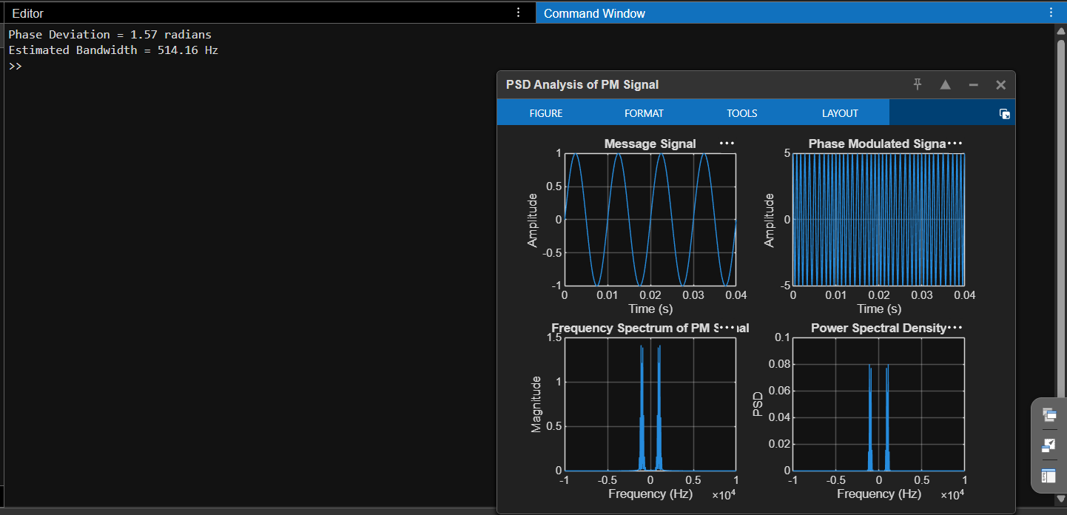
Figure 1. MATLAB plots showing the message signal, phase-modulated signal, frequency spectrum and PSD.
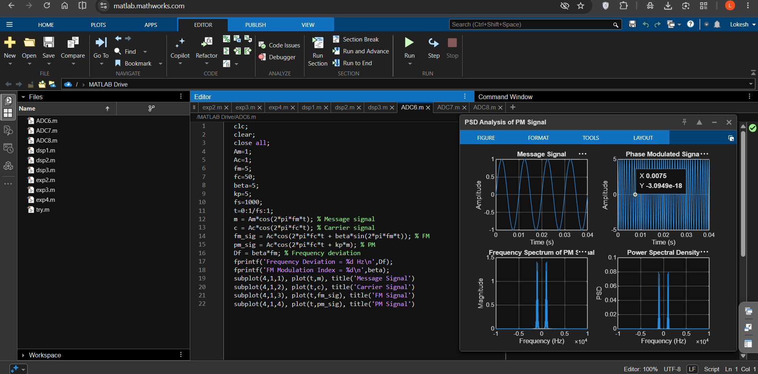
Figure 2. MATLAB Command Window and graphical output for PSD analysis.
4. Calculated Results
Parameter | Value
Message amplitude (Am) | 1 V
Message frequency (fm) | 100 Hz
Carrier amplitude (Ac) | 5 V
Carrier frequency (fc) | 1000 Hz
Sampling frequency (fs) | 20,000 Hz
Phase sensitivity (kp) | π/2 rad/V
Phase deviation (β = kp × Am) | 1.57 radians (approximately)
Estimated bandwidth (BW = 2(β + 1)fm) | 514.16 Hz (as displayed in the supplied output)
5. Applications
- Analysis and design of phase-modulated communication systems.
- Study of spectral characteristics in angle-modulation systems.
- Digital phase modulation systems, including Phase Shift Keying (PSK).
- Communication engineering laboratories for comparing signal spectra and power distribution.
6. Alignment with Analog and Digital Communication
This experiment demonstrates phase modulation and spectral analysis. The message signal changes the carrier phase according to the phase sensitivity, and the FFT-based plots show the frequency-domain characteristics and estimated power spectral density of the PM signal.
ADC Concept | Implementation | Observed Output
Message signal | 1 V, 100 Hz sinusoid | Message Signal plot
Phase modulation | pm = Ac*cos(2*pi*fc*t + kp*m) | Phase Modulated Signal plot
Phase deviation | β = kp × Am | Approximately 1.57 radians
Frequency spectrum | FFT and fftshift | Frequency Spectrum plot
Power spectral density | PSD = |FFT|²/(N × fs) | Power Spectral Density plot
Approximate bandwidth | BW = 2(β + 1)fm | 514.16 Hz as displayed in the supplied output
7. Justification
- The message and phase-modulated plots show the time-domain behavior of the PM system.
- The frequency spectrum shows how the signal's frequency components are distributed around the carrier.
- The PSD plot provides a view of how signal power is distributed across frequency.
- The phase deviation is calculated directly from phase sensitivity and message amplitude.
- The estimated bandwidth is reported using the formula implemented in the supplied MATLAB program.
8. Conclusion
A phase-modulated signal was generated and analyzed using MATLAB. The time-domain waveforms, frequency spectrum and power spectral density were plotted. The phase deviation was calculated as approximately 1.57 radians, and the estimated bandwidth was reported as 514.16 Hz in the supplied output.
DONE BY
Lokesh A
Register Number: 192512293
B.E. Electronics and Communication Engineering (ECE)

